**Mini Project Report - 02**

Master of Computer Application – General

Semester – III

**Sub: Web Technologies**

**Topic:** My Resume  
By  
**Name:** SANDRA B  
**Reg no.:** 24110222500001

**Faculty Name:** VEERA RAGHAV K

**Faculty Signature: _______________**

**Department of Computer Application  
Alliance University  
Chandapura - Anekal Main Road, Anekal  
Bengaluru - 562 106**

**August 2025**

|  |  |  |
| --- | --- | --- |
| **Sno.** | **INDEX** | **Page No.** |
| 1. | Introduction | 2 |
| 2. | Objective | 2 |
| 3. | Tools and Technologies Used | 2 |
| 4. | Structure of the Resume Webpage | 3 |
| 5. | Explanation of HTML Code | 4 |
| 6. | Explanation of CSS Code | 4 |
| 7. | Output | 5 |
| 8 | Advantages of a Web-Based Resume | 7 |
| 9. | Conclusion | 7 |

**Report on My Resume in Web Technologies**

**1. Introduction**

A resume is an essential document that provides a summary of an individual’s educational background, skills, projects, certifications, and achievements. Traditionally, resumes are created in printed formats using word processors, but with the rapid growth of digital technology, online resumes have become increasingly popular.

This project, titled **“My Resume in Web”**, presents the creation of a personal resume in the form of a webpage using **HTML (Hypertext Markup Language)** and **CSS (Cascading Style Sheets)**. The resume webpage highlights my educational qualifications, technical skills, projects, certifications, and hobbies, while also showcasing a professional layout and design.

The report explains the step-by-step process of developing this resume, its structure, the design considerations, and its importance in today’s digital world.

**2. Objectives of the Project**

The primary objectives of creating a resume in web format are:

1. **Digital Presence:** To design an online version of my resume that can be shared easily through a link rather than a document.
2. **Practical Application:** To apply my knowledge of HTML and CSS in building a fully functional and aesthetically pleasing webpage.
3. **Professional Branding:** To create a personal brand by showcasing my skills, achievements, and creativity.
4. **Interactive Layout:** To develop a resume that is more visually appealing and modern compared to static PDFs or Word files.
5. **Learning Opportunity:** To strengthen my understanding of frontend technologies while building a real-world project.

**3. Tools and Technologies Used**

The resume webpage has been built using the following technologies:

* **HTML (HyperText Markup Language):** For creating the structure of the webpage.
* **CSS (Cascading Style Sheets):** For styling and improving the visual presentation of the resume.
* **Image Integration:** A profile photo is added to give a personal touch.
* **Browser:** Any modern browser such as Google Chrome, Mozilla Firefox, or Microsoft Edge can be used to view the resume.

No backend language or database has been used since this project is purely focused on the **frontend design** of a resume.

**4. Structure of the Resume Webpage**

The resume webpage is divided into the following main sections:

1. **Header Section**
   * Title: *Resume*
   * Name, Email, and Contact details
   * Profile photo
2. **About Me Section**
   * A detailed description of personal background, academic journey, technical knowledge, and passion for creativity.
3. **Education Section**
   * Academic qualifications listed in chronological order, from Master’s to 10th grade.
4. **Technical Skills Section**
   * A list of programming languages, tools, and technologies learned.
5. **Projects Section**
   * Projects completed during academic and personal learning experiences.
6. **Certificates Section**
   * Certifications obtained from platforms like Coursera, LinkedIn, and HackerRank.
7. **Hobbies Section**
   * Personal interests and creative activities.
8. **Footer Section**
   * Date, Place, and Signature area.

**5. Explanation of HTML Code**

The resume is developed using structured HTML tags:

* <html>...</html> → Defines the start and end of the webpage.
* <head>...</head> → Contains metadata, title, and CSS style.
* <body>...</body> → Contains all visible content of the resume.
* <div class="r">...</div> → Wraps the entire resume inside a bordered layout.
* <h1>, <h2>, <h3> → Used for headings and subheadings.
* <p> → Paragraphs for description.
* <ul><li> → Lists used for education, skills, projects, and hobbies.
* <img> → Displays the profile picture with styling.

Each tag is used carefully to ensure that the structure remains clean and readable.

**6. Explanation of CSS Code**

CSS has been used to enhance the visual appeal of the resume. Important CSS features used:

1. **Borders:**

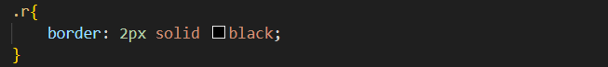

This places a neat border around the resume content.

1. **Headings:**

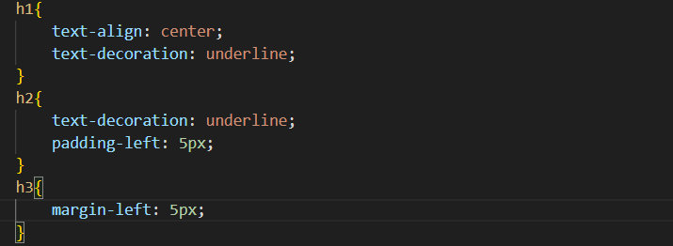

Ensures headings are underlined and properly aligned.

1. **Profile Image:**

Displays the photo in a circular frame at the top-right corner.

1. **Signature Section:**

Places the signature text at the bottom-right corner of the page.

**7. Output of the Project**

When the HTML file is executed in a browser:

1. A well-structured resume appears with proper alignment and styling.
2. The profile photo is displayed at the top-right corner in a circular frame.
3. Each section (About Me, Education, Skills, etc.) is neatly separated by horizontal lines (<hr>).
4. At the bottom, date, place, and signature section provide a formal finish.

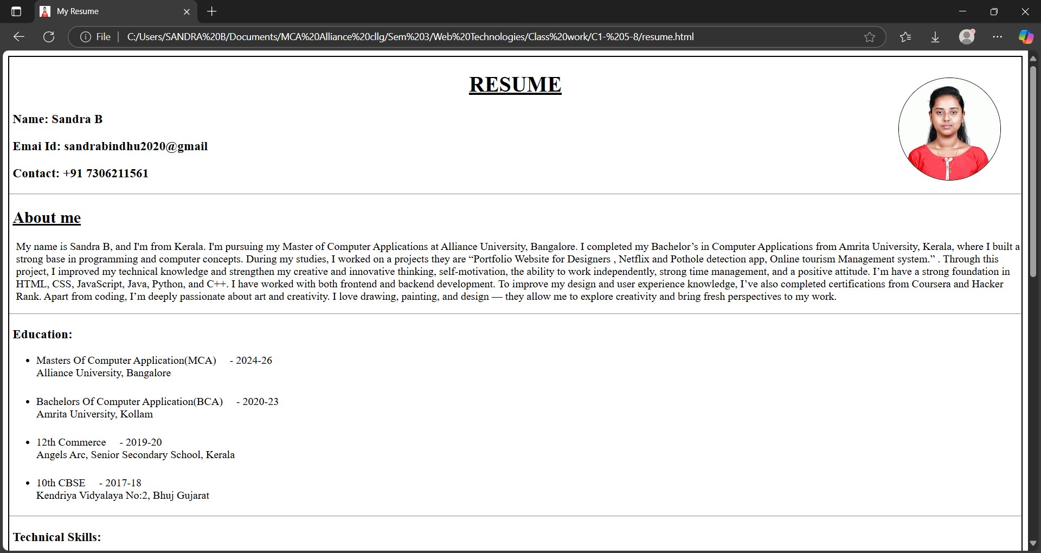

**8. Advantages of a Web-Based Resume**

1. **Accessibility:** Can be accessed from anywhere with a web browser.
2. **Shareability:** Easy to share via a link instead of sending bulky files.
3. **Customization:** Can be updated instantly compared to static resumes.
4. **Professional Appeal:** Makes a stronger impression in technical fields.
5. **Learning Opportunity:** Helps in practicing real-world HTML/CSS skills.

**9. Conclusion**

The project **“My Resume in Web”** successfully demonstrates how a personal resume can be transformed into an attractive and professional webpage using HTML and CSS. The resume webpage is structured, user-friendly, and visually appealing.

It not only showcases personal and academic details but also reflects creativity, technical skills, and professional branding. In today’s competitive environment, such web-based resumes can play a crucial role in personal branding and career advancement.

This project helped in gaining practical exposure to web technologies, enhancing design skills, and understanding the importance of digital presentation.